Design Implementation for Model Building

* We have built models and associated each of them with a web service. For the 10 models, we have 10 different web services.
* For accepting user inputs through a web platform, we have used **Flask**.
* Flask was chosen over Pyramid or Django as Flask is very convenient to build small applications with ease.
* We are accepting the user’s choice of Prediction, Classification or Clustering by utilizing the framework of Flask.
* We have utilized the service called ‘**RRS’,** a Request Response Web Service that represent the Azure ML experiments over Public API’s in the form of REST API.

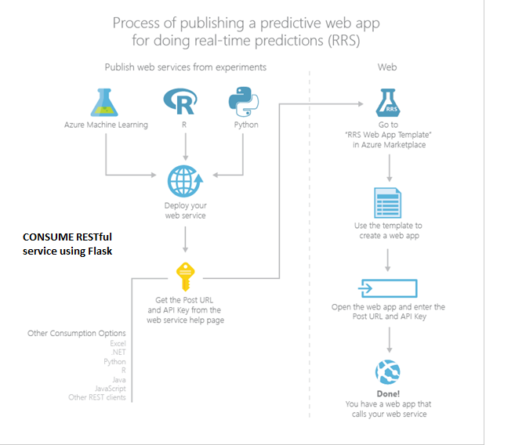

Creating ML Service Web App using RRS (ASP.NET)

1. Retrieve the created API and the URL of a web service from Web Services tab in Azure Machine Learning Portal

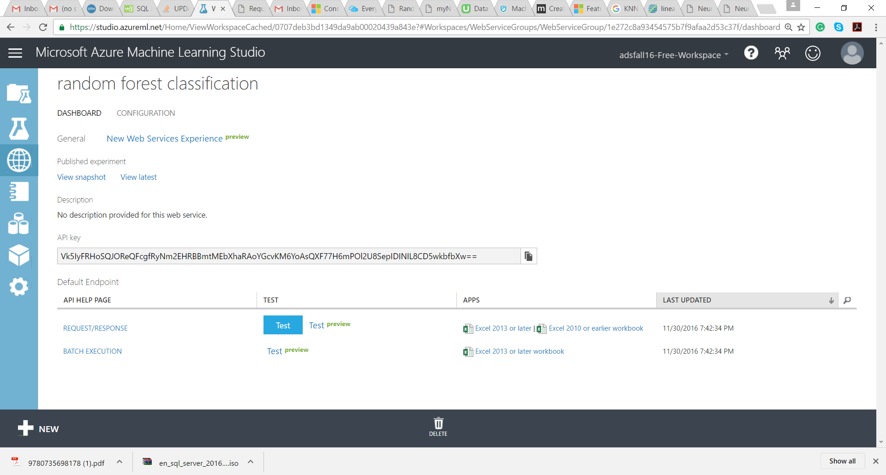



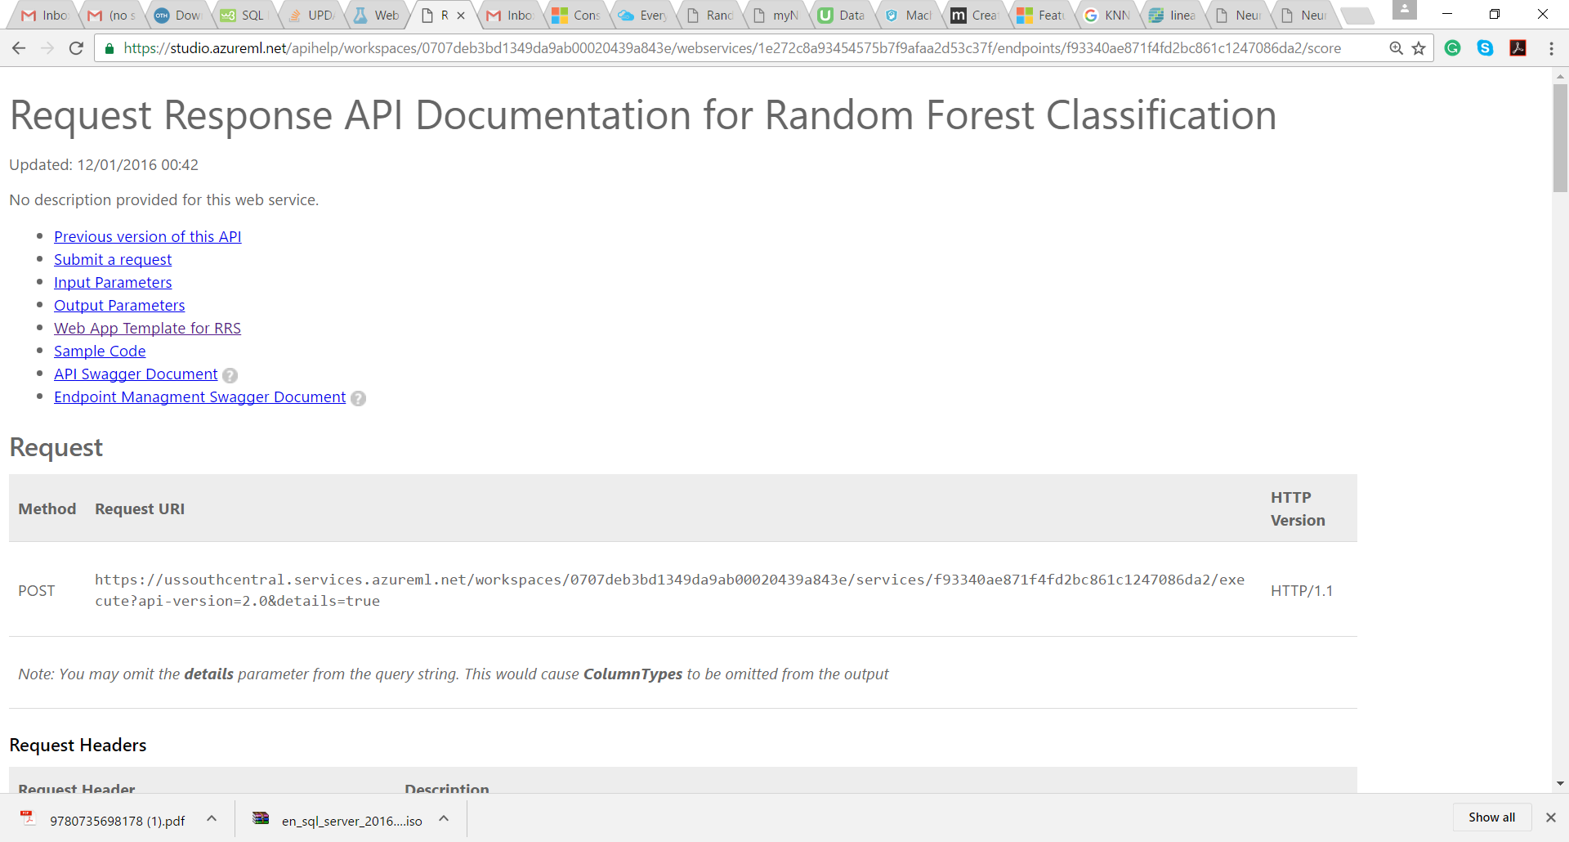

1. Now logon to Azure Portal and search for Azure ML Request Response Service Web App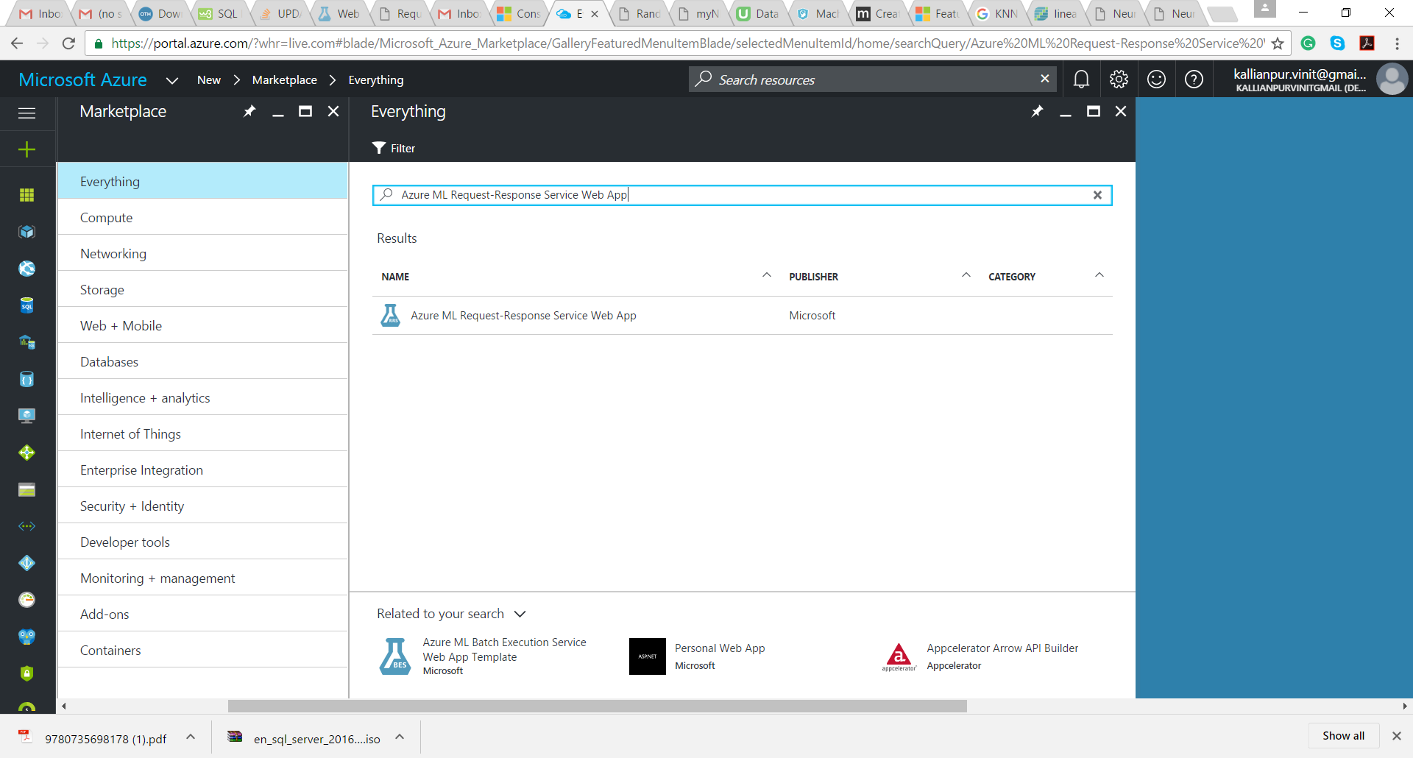
2. Click on it and then click on create button 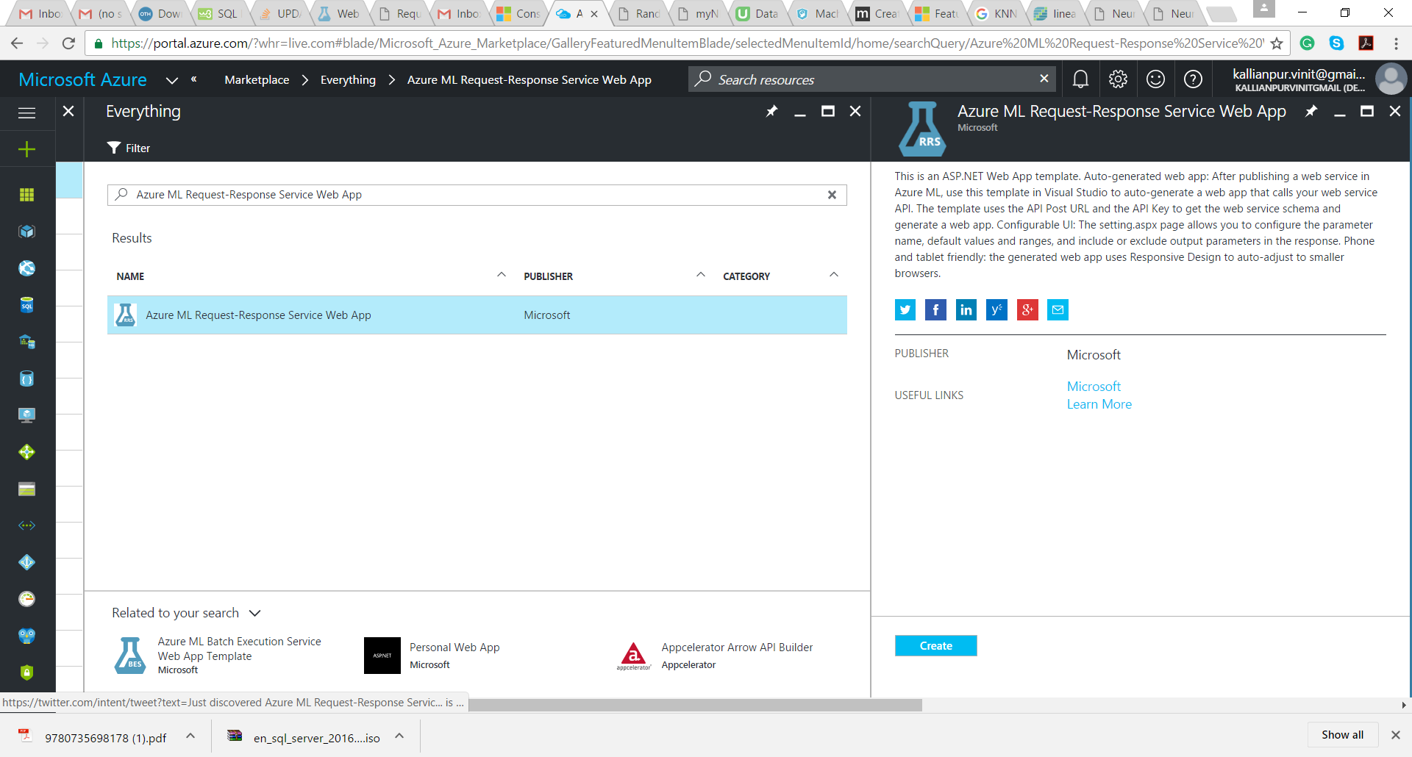
3. Now input values based on the web services selected as follows

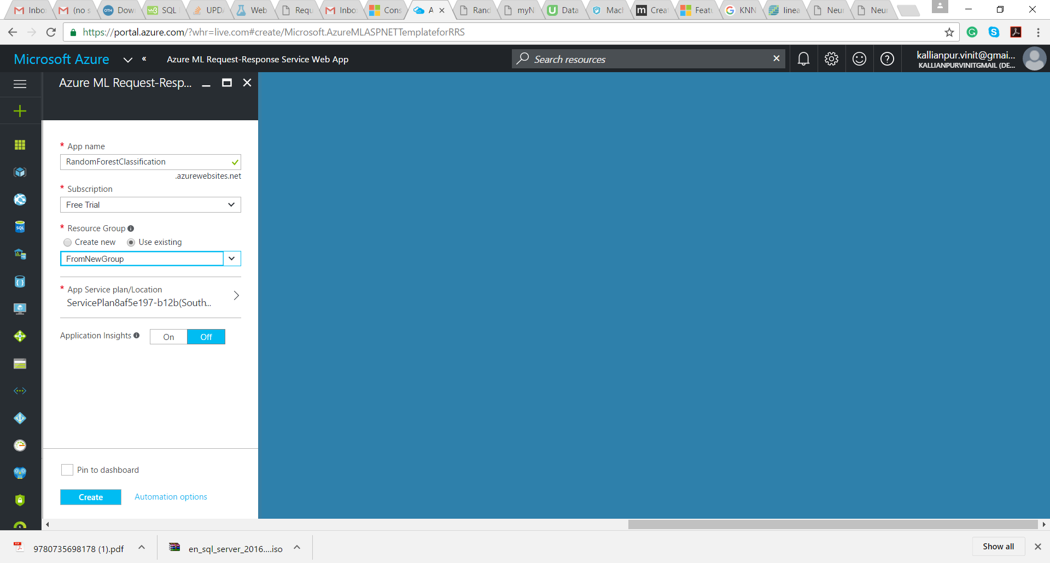

1. Wait for the service to get deployed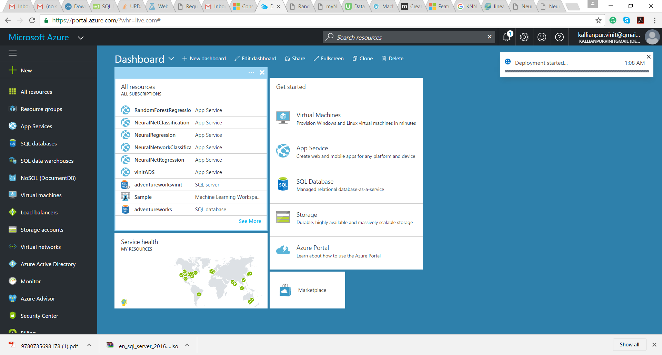

Wait till the deployment is a success and click on the Deployment

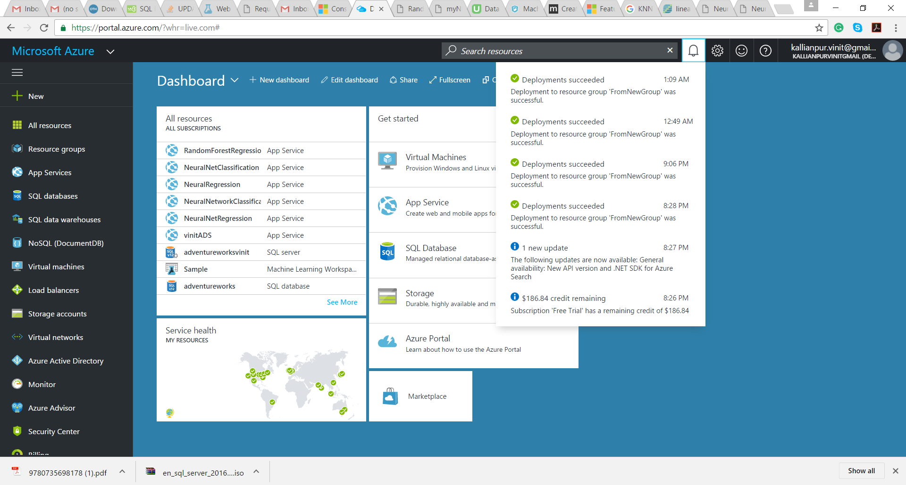

1. Click on resource link

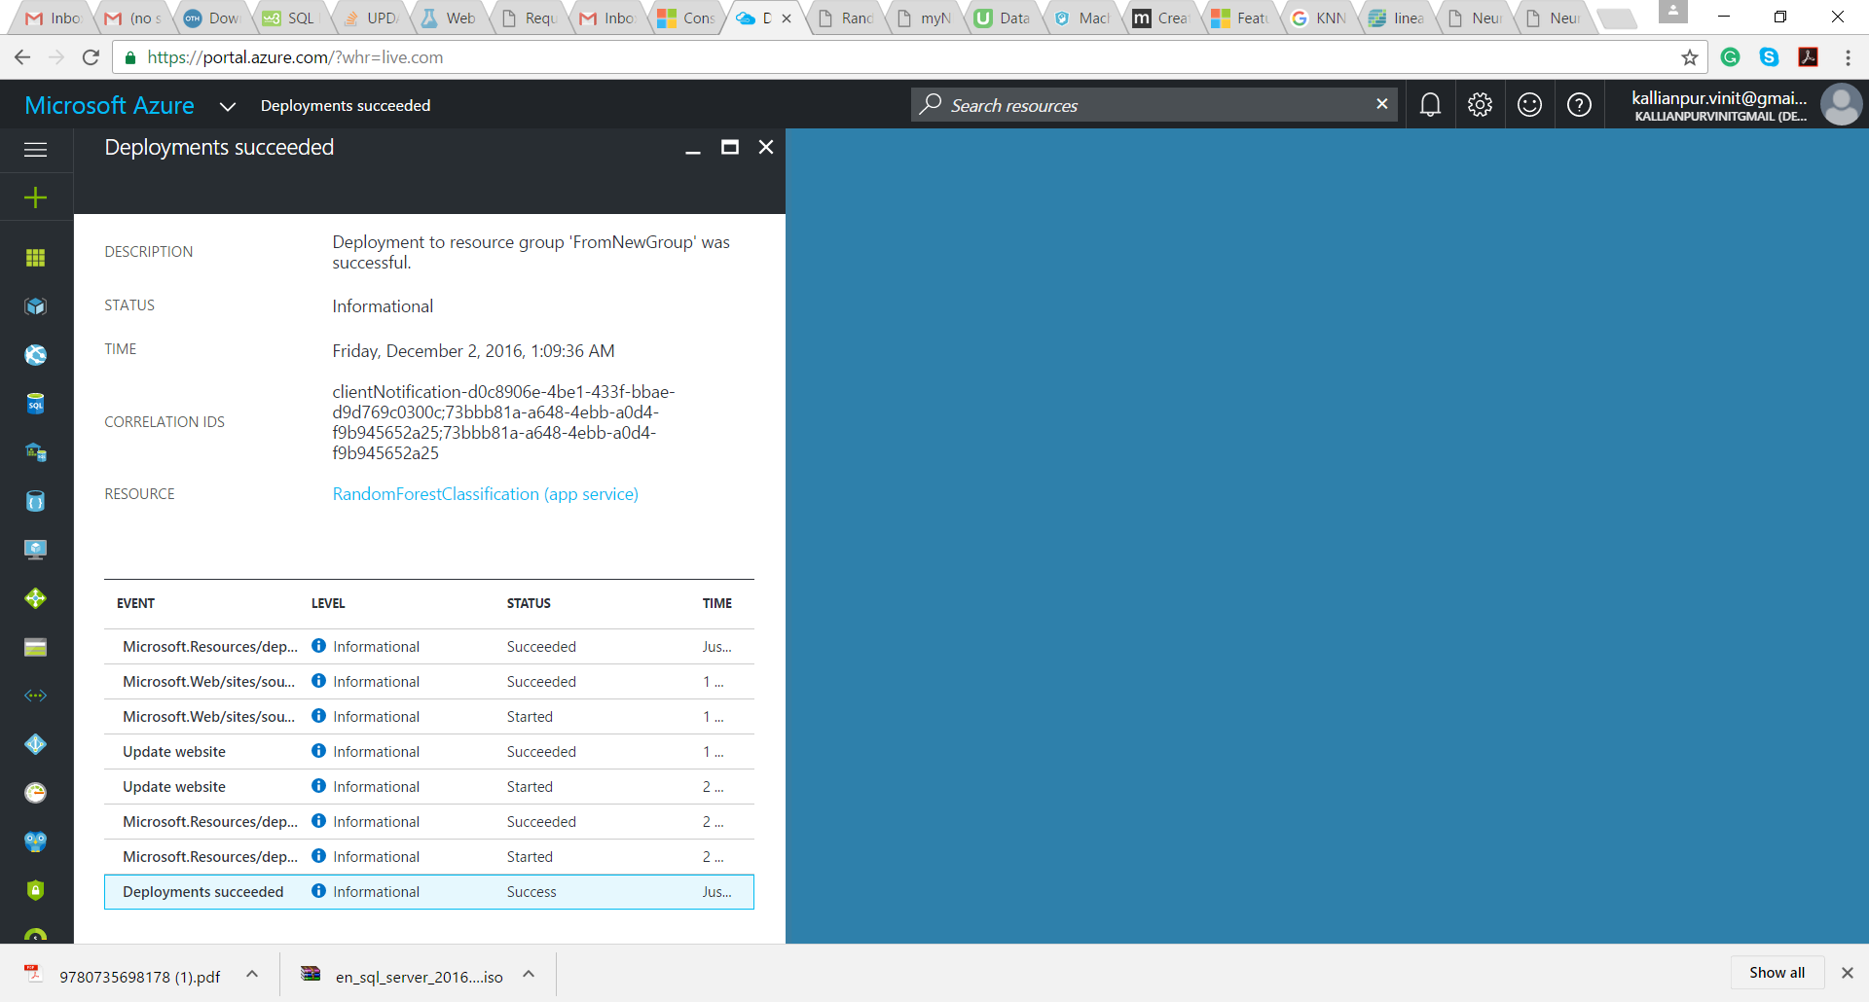

1. Click on URL displayed at the right hand side:

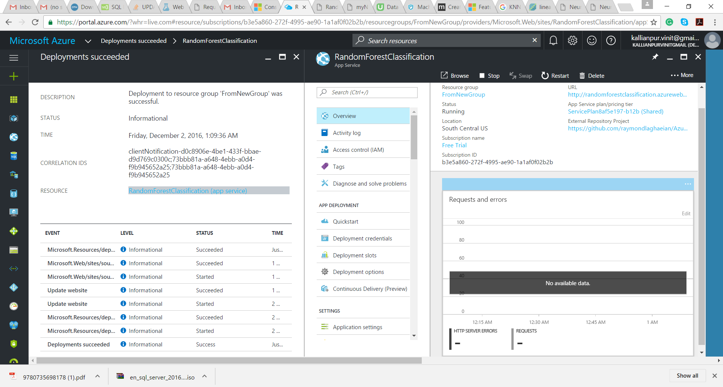

1. Enter URL and API key, input values that was obtained from Step 1

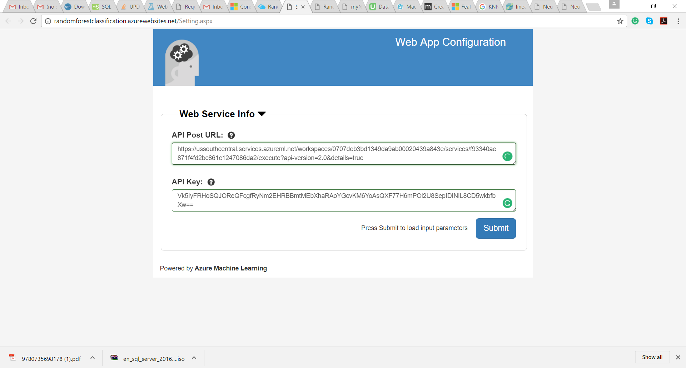



1. Now set the default values based on your requirement.

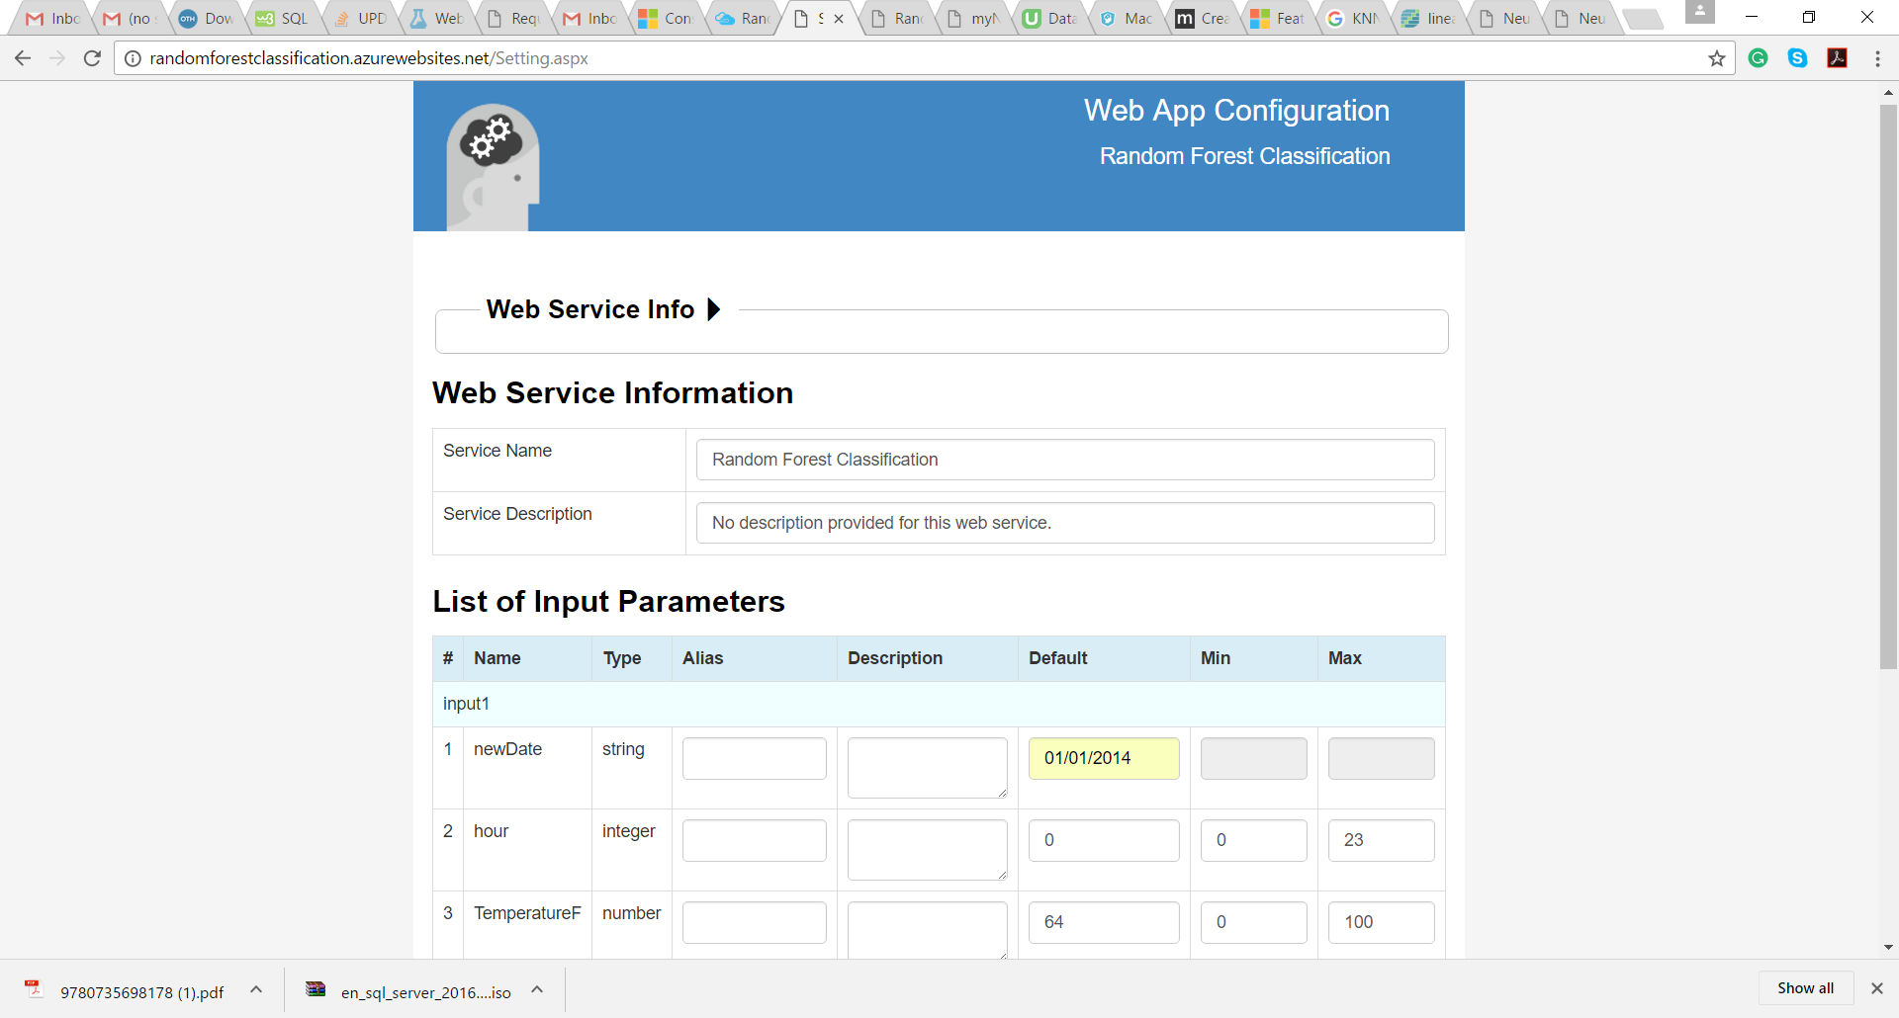

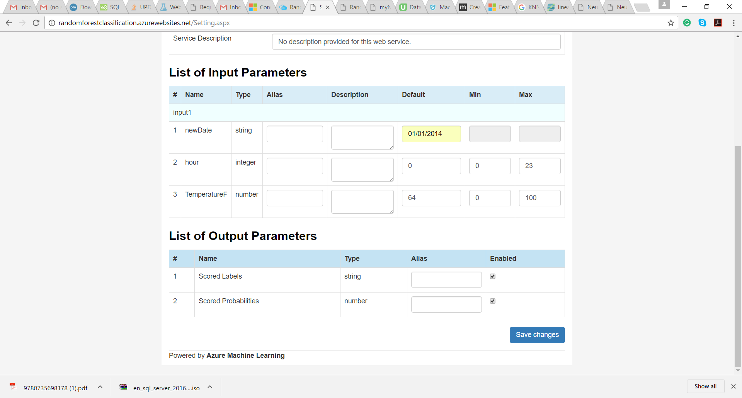

1. Click on Go to Home Page button. 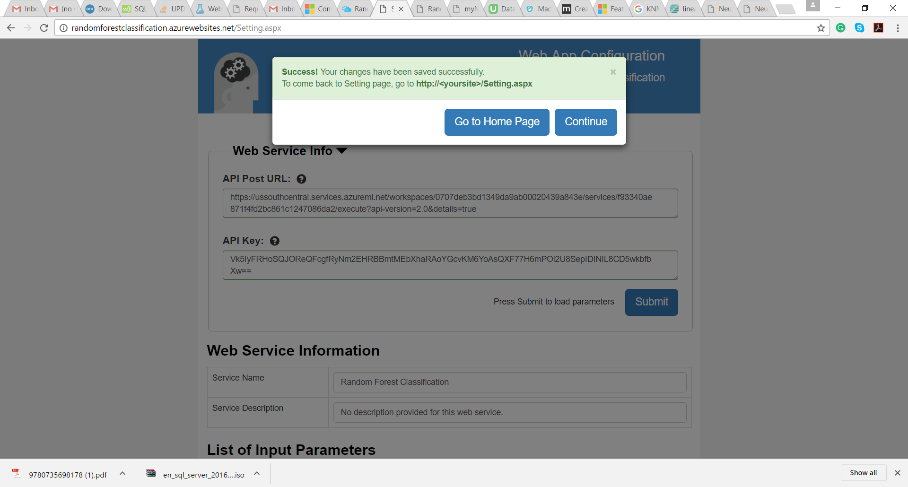
2. The web service is ready for consumption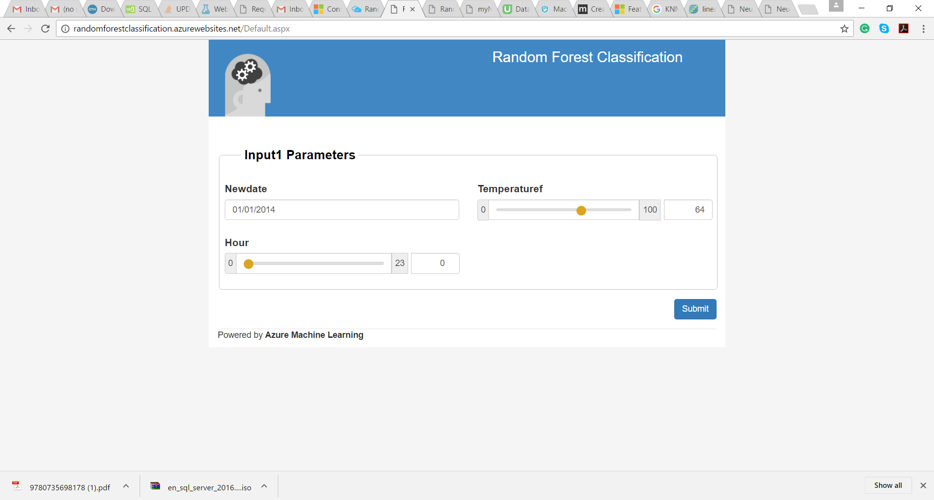

PREDICTION

1. Linear Regression

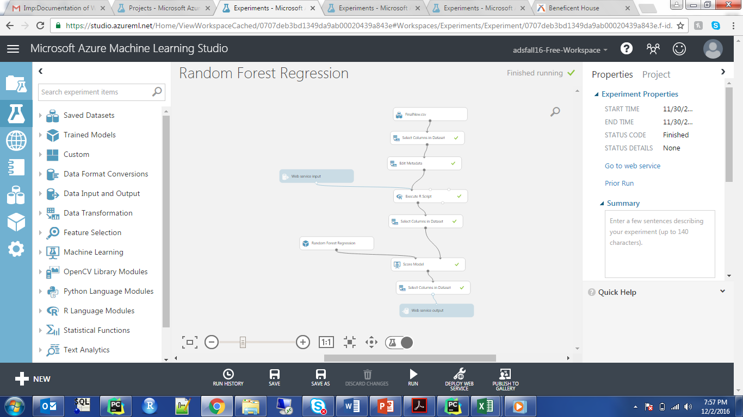

1. Neural Net Regression

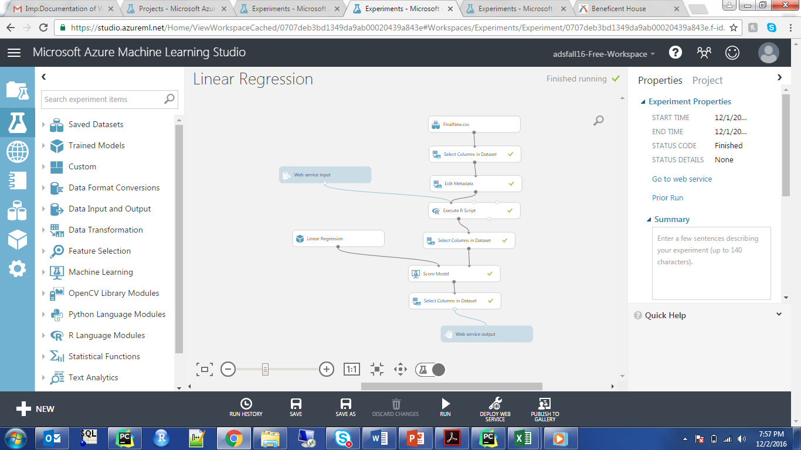

1. KNN Regression

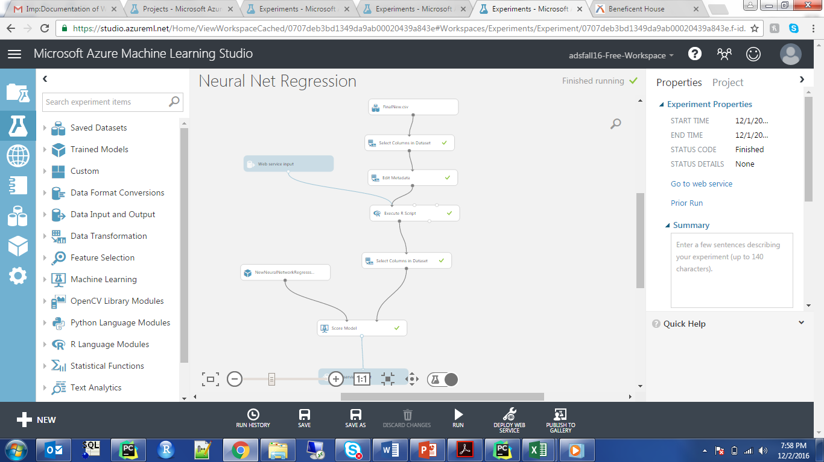

1. Random Forest

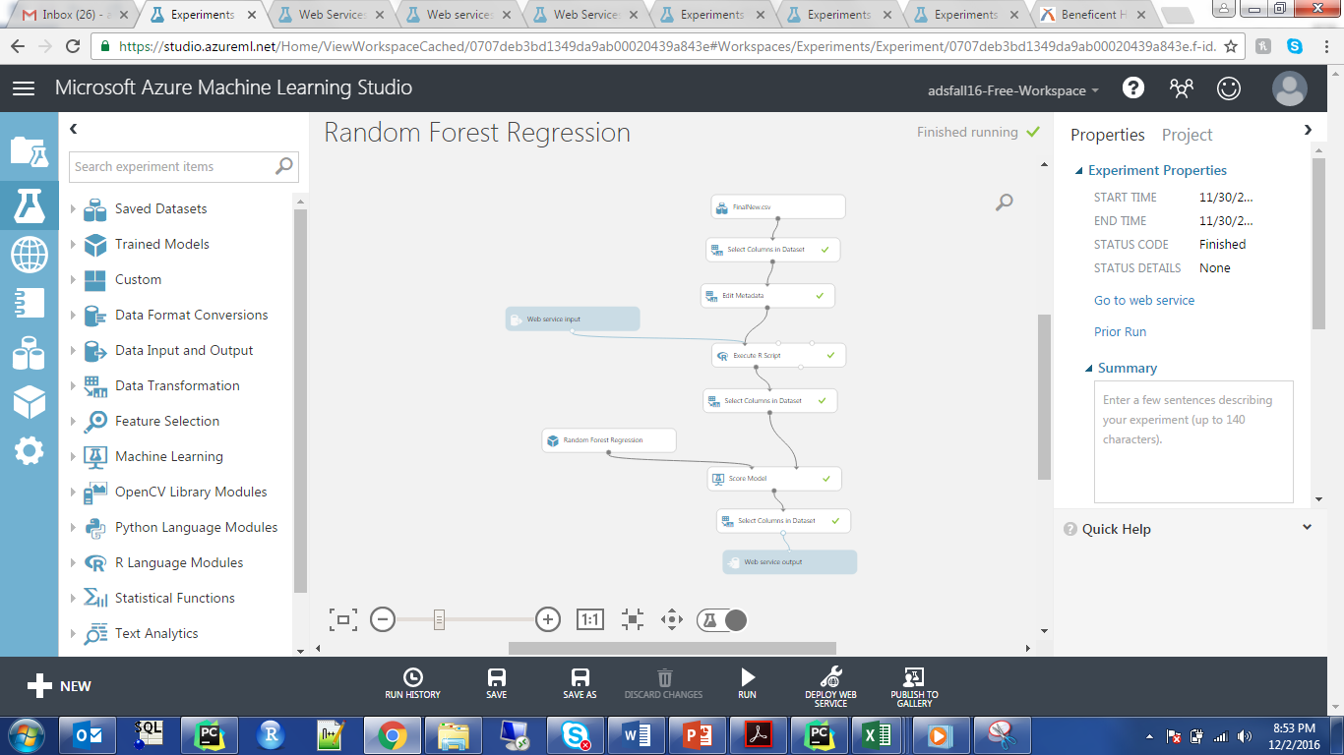

CLASSIFICATION

1. Random Forest

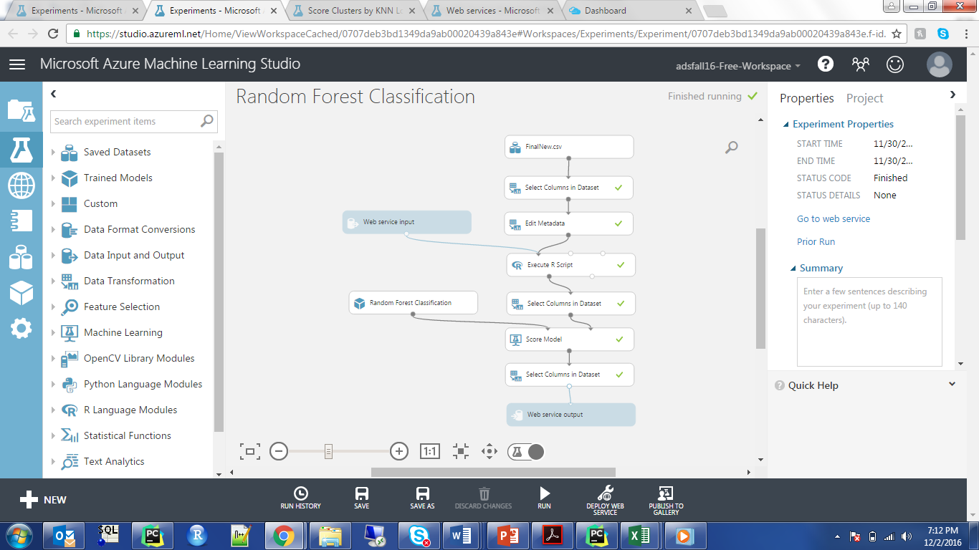

1. Neural Net

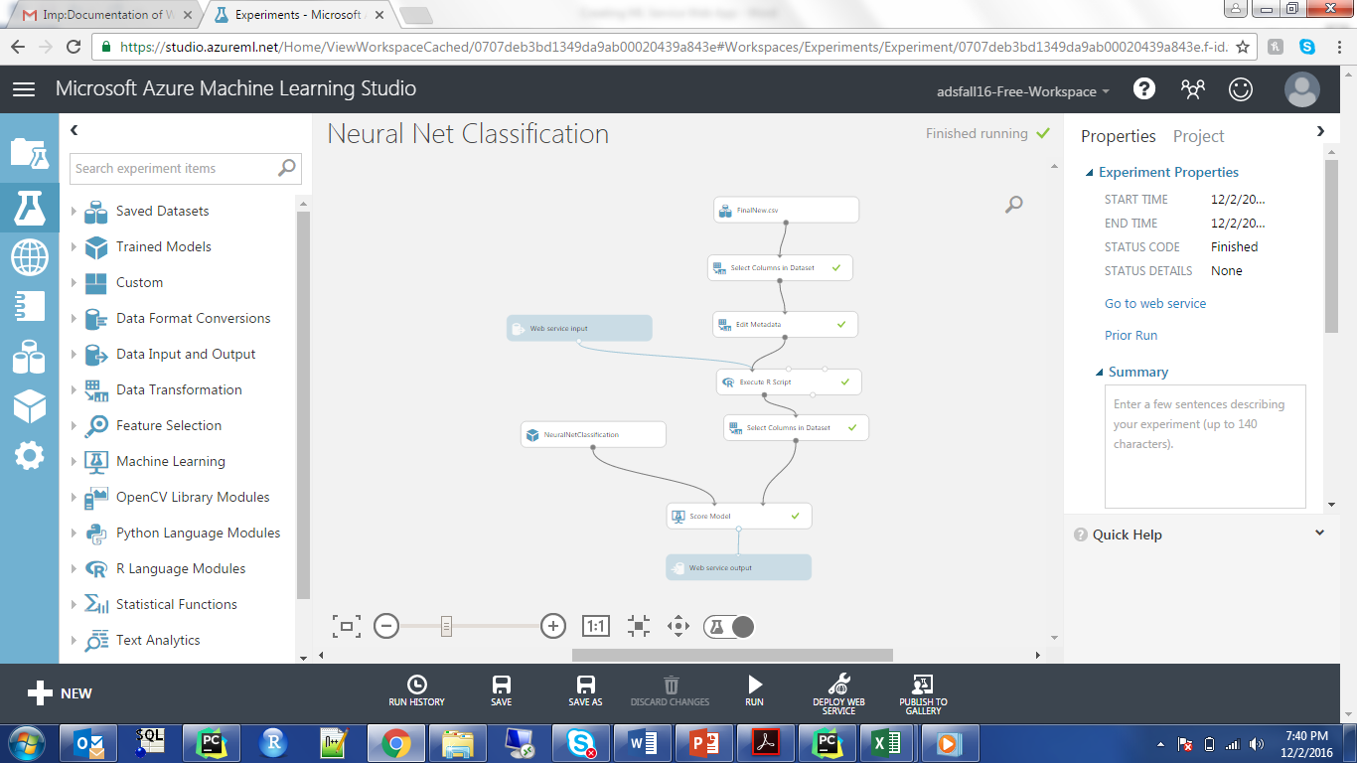

3. Logistical

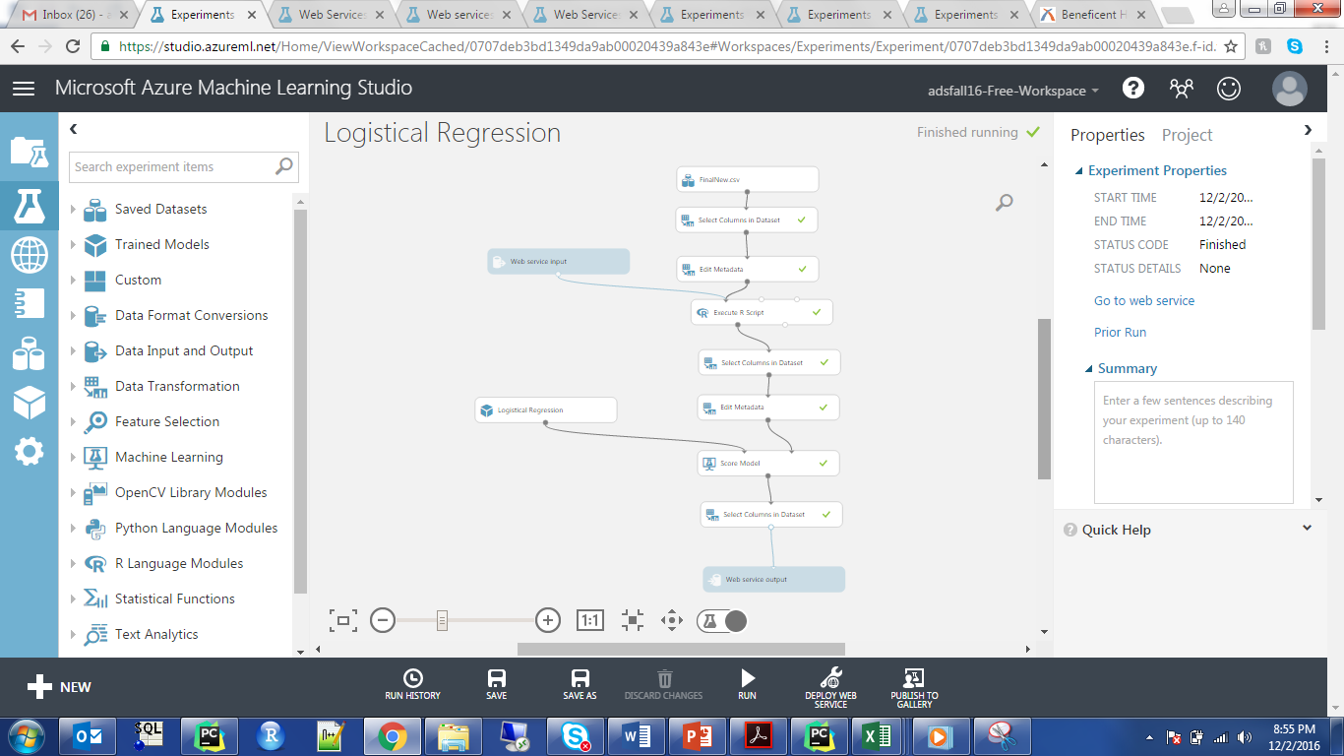

CLUSTERING

1. K-Means

